**Online Movie Ticket Booking**

**Project Description:**

These days movies are the best entertainment to us. Every person faces different types of problems every day. So movies are a highly recommended way to release our stress. By watching any movie we automatically feel like we are in another different world. Where we will be able to forget our problems even for a few hours because movies are filled with a lot of emotions and feelings by watching movies we cannot solve our problems but at least we are able to stop thinking about those problems. Watching movies in the theatre with family or friends is the best experience.

For movie tickets, online booking is the better platform to book the ticket. Because we can reserve our seats and also have the facility to choose seats before goto theatre, so,if the theatre is also housefull we can not regret it. And also we can save time. For this purpose only we can develop the best website that is “ Online Movie Ticket Booking”.

In our project we have two modules , Admin and Audience. Admin can login with default credentials. Admin can add the different languages because we can watch the movies in different languages like english, hindi, telugu, tamil etc and also admin can view the added languages. Admin can add the movies and also admin can view the added movies.The admin can add the multiplexes and also admin can view the added multiplexes.while adding the multiplex the admin can mention the screens for particular multiplex and also the show timings, The admin can view the added screens and show timings. Admin can assign the movies for particular multiplexes with screen, show timings, movie type (2D, 3D, 4DX), and ticket price. And also admin can view the assigned movies. The audiences can register with name, email, password, phone and login with registered email and password. The audiences can search the movies with languages , movie names then the audience can view the movies. Audience can view the multiplexes and then the audience can book the seats by choosing language, movie name, multiplex, screen and show timings. And then the audience can pay the amount for bookings. The audience can view the bookings if the audience wants to cancel the booking then they can cancel the booking. Audience can view the payments.admin and the audience can view booking history.

**Admin Activities:**

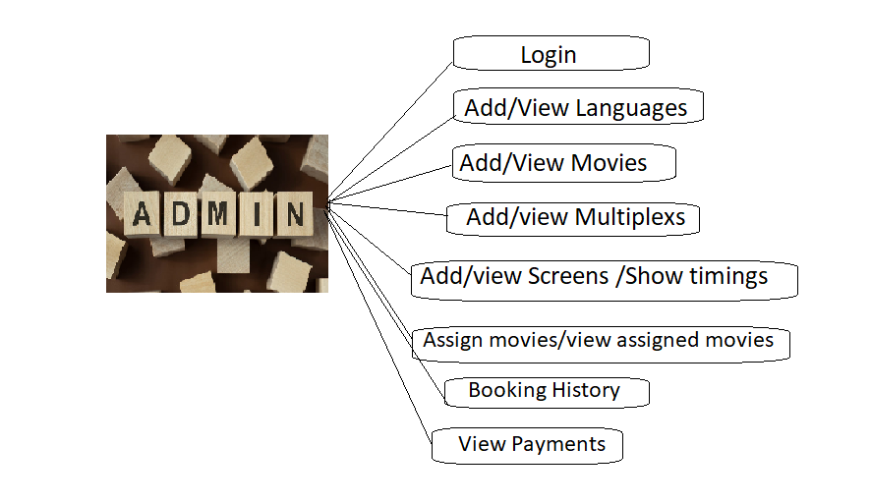

**Audience Activities:**

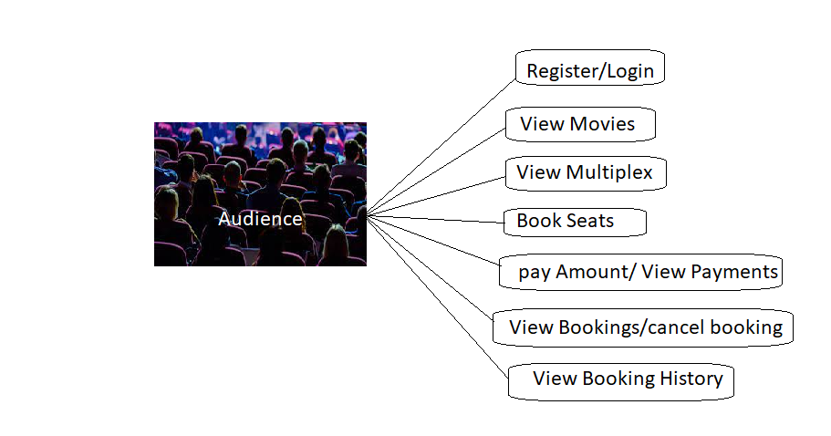

**References:**

* B. Hang, "Design and Implementation of Cinema Online Booking System," 2011 International Symposium on Computer Science and Society, Kota Kinabalu, Malaysia, 2011, pp. 196-199, doi: 10.1109/ISCCS.2011.61.